Killington Grand Resort Hotel & Conference Center Meeting Space Layout
E = Northstar II
- AM – Workshop D
- Ignite Session 4
- PM – Session M

4

6

K = Roundabout
- AM – Workshop A
- Ignite Session 1

1 = Gateway I
- AM – Workshop F
- PM – Workshop O

1

To Trail Creek

Oscar Wilde Ballroom III
Strand D
Workshop F
Oscar Wilde Ballroom II
Strand D
Workshop C

E = Escapade I and II
- AM – Workshop H
- PM – Workshop Q

5

= Oscar Wilde Ballroom II
- AM – Workshop B
- PM – Workshop I

7

2

G = Gateway II
- AM – Workshop E
- Ignite Session 2
- PM – Workshop N

= Oscar Wilde Ballroom III
- AM – Workshop G
- PM – Workshop P

3

D = Northstar I
- AM – Workshop C
- Ignite Session 3
- PM – Workshop J

8

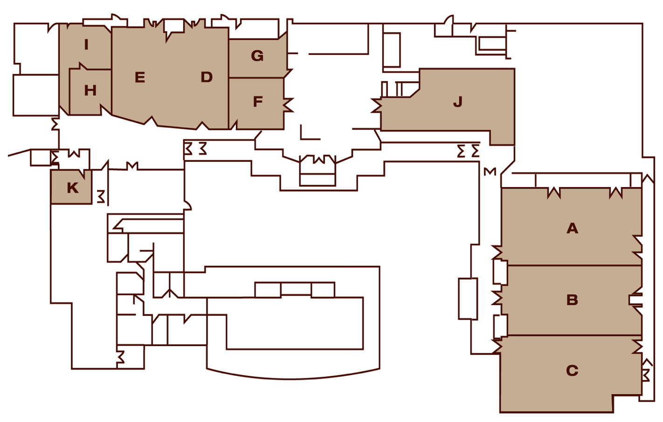

5

Elevators
Restrooms

2

3

4

Preston’s
Restaurant

1

Restrooms

Kitchen
Lower Lobby

Northstar
Promenade

66
Restrooms

The Spa

Terrace Patio

Health Club

7 Oscar Wilde Ballroom II

8 Oscar Wilde Ballroom III

Promenade
Outdoor Heated Pool

